1. Requirement Gathering

Online Cosmetic

2. Analysis & SRS

**Step: 1 Define module/user/actor**

Guest                  => Website

Customer => Website

Admin                => Admin panel

**Step: 2 Define each module Task**

**Guest**

View category

View Product

View Blog

Contact us

**Customer**

View category

View category

Contact us

View Blog

Register

Login

Manage profile

Add to cart

Manage CART

Place order

Manage Order

Logout

**Admin:**

Login

Manage category

Mange Product

Manage Blog

View Contact Reports

Manage Customer Reports

View Cart Reports

View Order Reports

Logout

**Step :3 As per task define all diagram**

**Use Case diagram**

Step 3 Diagrams

**1** use case diagram

**Guest:**

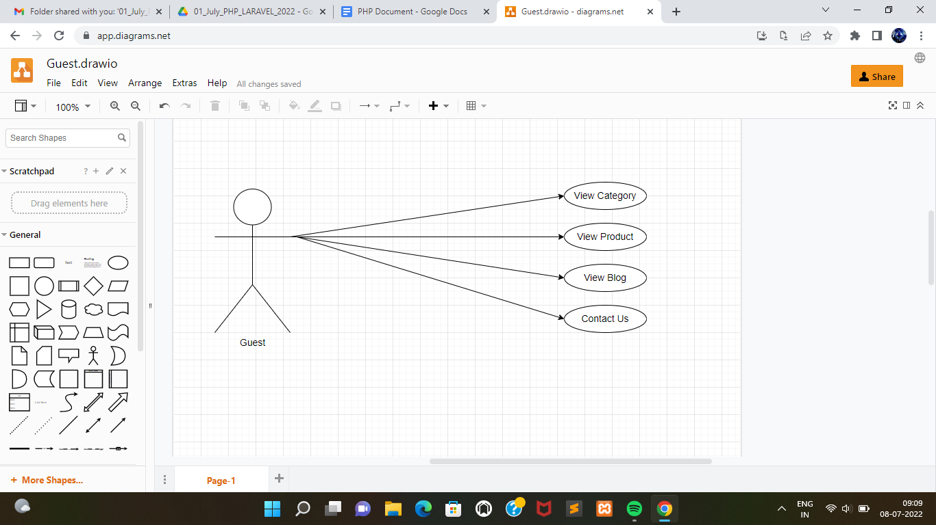

**Customer:**

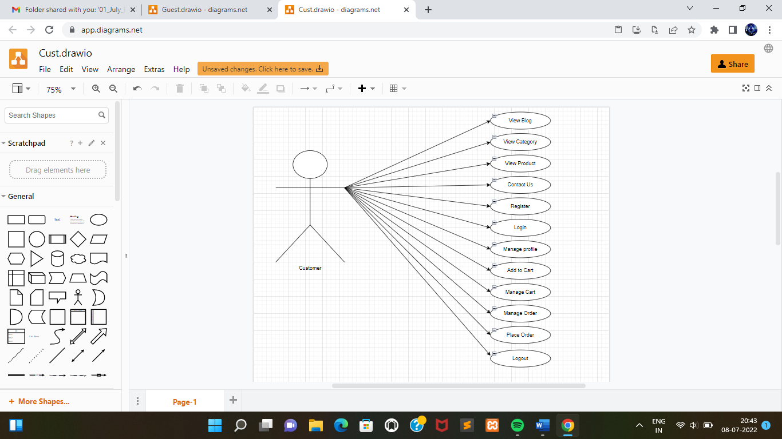

**Admin:**

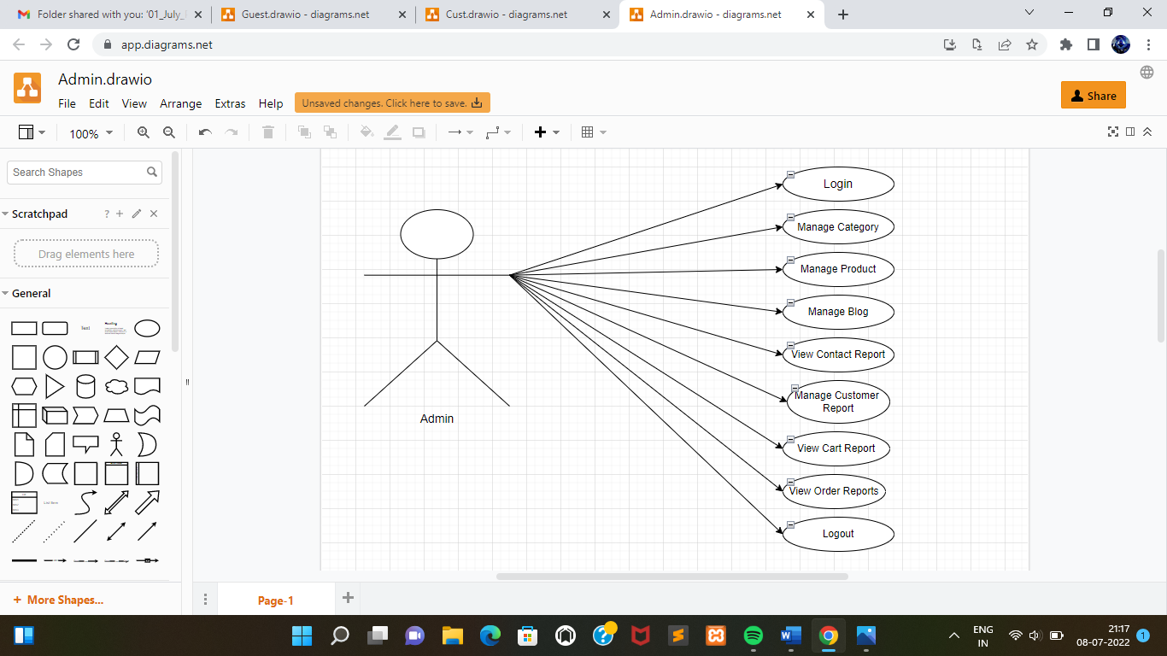

**2** DFD Data flow diagram

0 level

1 level

**0 level / context level**

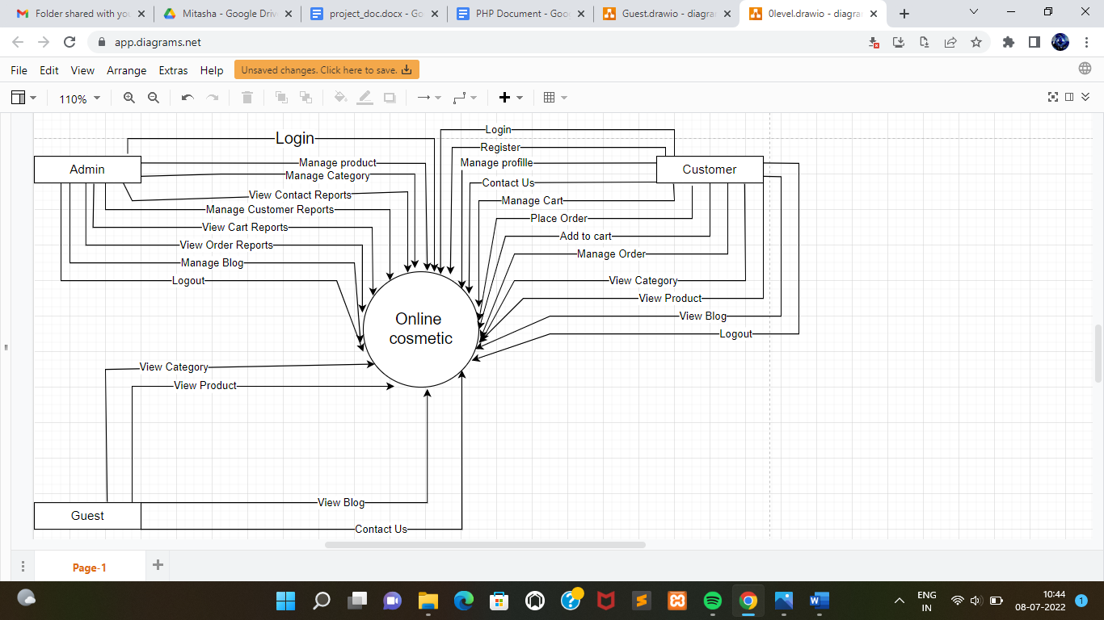

**Level 1**

Admin DFD

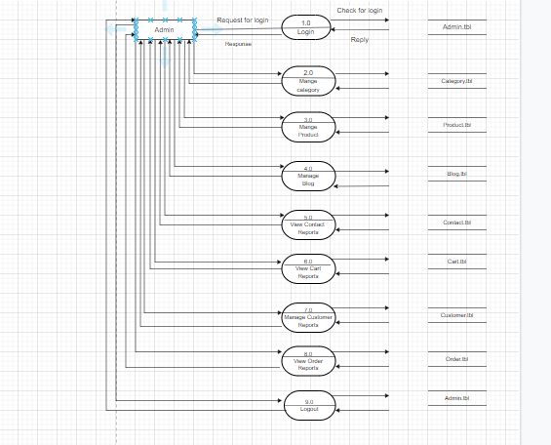

Customer DFD:

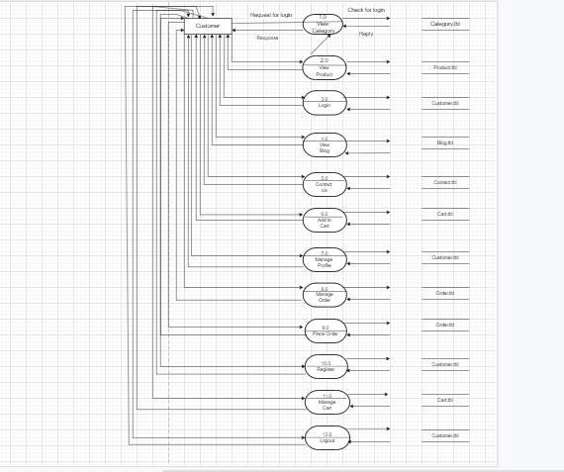

 Step 4: Find Total Number of table

categories.tbl

product.tbl

contact.tbl

customer.tbl

cart.tbl

order.tbl

blog.tbl

Admin.tbl

**Step: 5  Define each table column**

categories.tbl

**Categorie_id  int PK**

Cate_name

Cate_img

**Created_dt**

**Updated_dt**

**Product.tbl**

**Product_id  int PK**

Categorie_id  int FK

Prod_name

Prod_mainprice

Prod_discprice

Prod_img

Prod_desc

**Created_dt**

**Updated_dt**

**contact.tbl**

**Contact_id PK**

Name

Email

Comment

**Created_dt**

**Updated_dt**

**customer.tbl**

**Cust_id PK**

Name

Username

Password

Email

Mobile

Address

**Created_dt**

**Updated_dt**

**Cart.tbl**

**Cart_id  PK**

Product_id  int FK

Qty

**Created_dt**

**Updated_dt**

Order.tbl

**Order_id   PK**

Cust_id FK

Cart_id FK

Total Amount

**Created_dt**

**Updated_dt**

Admin.tbl

**Admin_id   PK**

Username

Password

**Created_dt**

**Updated_dt**

**AS ABOVE COLUMN CREATE DATA DICTIONARY**

Categorie.tbl

|  |  |  |  |  |
| --- | --- | --- | --- | --- |
| Field Name | Data Type | Field Length | Constraint | Description |
| Categorie_id | int | 10 | primary | Categorie id, auto generated |
| Cate_name | varchar | 50 | Not null | Name of categorie table |
| Cate_img | varchar |  | Not null | Image of categorie table |
| Created_dt | date |  | Not null | Ctreate table |
| Updated_dt | date |  | Not null | Update table |

Product.tbl

|  |  |  |  |  |
| --- | --- | --- | --- | --- |
| Field Name | Data Type | Field Length | Constraint | Description |
| Product_id | int | 10 | primary key | product id , auto generated |
| Categorie_id | int | 10 | Foreign Key | categorie  id , foreign key use |
| Prod_name | varchar | 50 | not null | name of product name table |
| Prod_mainprice | int | 5 | not null | main price of product table |
| Prod_discprice | int | 10 | not null | discount  of product price table |
| Prod_img | varchar | 25 | not null | image  of product table |
| Prod_desc | varchar | 150 | not null | description  of product table |
| Created_dt | date |  | not null | created table |
| Updated_dt | date |  | not null | updated table |

Contact.tbl

|  |  |  |  |  |
| --- | --- | --- | --- | --- |
| Field Name | Data Type | Field Length | Constraint | Description |
| Contact_id | int | 10 | primary key | contact  id , auto generated |
| Name | varchar | 50 | not null | name of contact  name |
| Email | varchar | 50 | not null | email  of contact table |
| Comment | varchar | 200 | not null | comment  of contact table |
| Created_dt | date |  | not null | created table |
| Updated_dt | date |  | not null | updated table |

Customer.tbl

|  |  |  |  |  |
| --- | --- | --- | --- | --- |
| Field Name | Data Type | Field Length | Constraint | Description |
| Cust_id | int | 10 | primary key | customer  id , auto generated |
| Name | varchar | 50 | not null | name of customer  name |
| Username | varchar | 50 | not null | user name of customer table |
| Password | varchar | 10 | not null | password of customer  table |
| Email | varchar | 12 | not null | email of customer  table |
| mobile | varchar | 10 | not null | mobile of customer  table |
| Address | varchar | 50 | not null | Address of customer table |
| Created_dt | date |  | not null | created table |
| Updated_dt | date |  | not null | updated table |

  Cart.tbl

|  |  |  |  |  |
| --- | --- | --- | --- | --- |
| Field Name | Data Type | Field Length | Constraint | Description |
| Cart_id | int | 10 | primary key | cart  id , auto generated |
| Product_id | int | 10 | foreign key | product  id ,  foreign key use |
| qty | int | 10 | not null | qty of cart table |
| Created_dt | date |  | not null | created table |
| Updated_dt | date |  | not null | updated table |

Order.tbl

|  |  |  |  |  |
| --- | --- | --- | --- | --- |
| Field Name | Data Type | Field Length | Constraint | Description |
| Order_id | int | 10 | primary key | order  id , auto generated |
| Cust_id | int | 10 | foreign key | cust  id ,  foreign key use |
| Cart_id | int | 10 | foreign key | cart  id ,  foreign key use |
| Total Amount | int | 20 | not null | total amount  of order table |
| Created_dt | date |  | not null | created table |
| Updated_dt | date |  | not null | updated table |

Blog.tbl

|  |  |  |  |  |
| --- | --- | --- | --- | --- |
| Field Name | Data Type | Field Length | Constraint | Description |
| Blog_id | int | 10 | primary key | order  id , auto generated |
| Title | varchar | 20 | not null | title  of blog table |
| Img | varchar | 25 | not null | image   of blog table |
| Description | varchar | 200 | not null | description  of blog  table |
| Created_dt | date |  | not null | created  table |
| Updated_dt | date |  | not null | updated  table |

Admin.tbl

|  |  |  |  |  |
| --- | --- | --- | --- | --- |
| Field Name | Data Type | Field Length | Constraint | Description |
| Admin_id | int | 10 | primary key | admin  id , auto generated |
| Username | varchar | 10 | not null | user name od admin table |
| password | varchar | 10 | not null | password of admin table |
| Created_dt | date |  | not null | created table |
| Updated_dt | date |  | not null | updated  table |

**3.** Designing

**4.** Implementation (Coding)

**5.** Testing

**6.** Maintenance